

**School of Information Technology**

Course : Diploma in Business Informatics

Subject : ITP282 - Enterprise Application Development & Project

AY / Sem : 2018 S2

**Lab 5e**: Stored Procedures

**OBJECTIVES**:

By the end of this Practical students should be able to:

1. Understand what is a Stored Procedure
2. Be able to call a stored procedure from a program

**Lab 5e: Stored Procedures**

In this practical, you will explore what is a Stored Procedure, understand its advantages, and learn how to call it from your C# code.

All the SQL queries you have used so far is contained within your C# code. Although you saw that this works effectively with simple SELECT, INSERT, UPDATE and DELETE queries, writing a query this way is not always a suitable solution for more complex requirements.

Stored Procedures provide another way for executing queries against a database. Stored Procedures are programs that are *stored in the SQL server*, as named collections, very similar to what functions/sub procedures is to VB and methods is to C#. Once created, these Stored Procedures can be called from C# or VB code. Like functions or methods, Stored Procedures may contain none, one or more input and output parameters. We will be learning how to write Stored Procedures with input and output parameters later in this practical. It may also contain variables, looping, branching etc just like the programming languages you are familiar with.

When do you use Stored Procedures? If you are developing a relatively simple application with low usage, then keeping your SQL statements in your program is perfectly fine. However, in many more complex multi user applications, using stored procedures may be the way to go. Some the benefits of using Stored Procedure are:

* They allow you to encapsulate code. In other words, the database operation appears once, in the stored procedure, not multiple times throughout your application source. This improves debugging as well as maintainability.
* Changes to the database schema affect your source code in only one place, the stored procedure. Any schema changes then become a DBA task rather than a wholesale code revision.
* Since the stored procedures reside on the server, you can set tighter security restrictions on the client space, saving more trusted database permissions for the well-protected stored procedures themselves.
* Since stored procedures are compiled and stored outside the application, they can use more sensitive variables within the SQL syntax, such as passwords or personal data that you would avoid using in scripts or remote calls.
* Using stored procedures greatly reduces network traffic.

**Exercise 1: Calling Stored Procedure without Parameter**

* 1. Double click on DVDshop.mdf to view it in Server Explorer.
  2. Redo **Lab5a 1 Ex4** by creating a Stored Procedure call **getProductPricing** as follows:

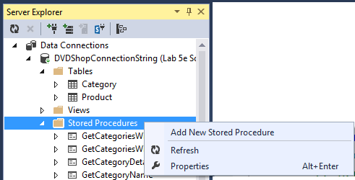

* 1. Enter the Stored Procedure as following, and click on the Update button.

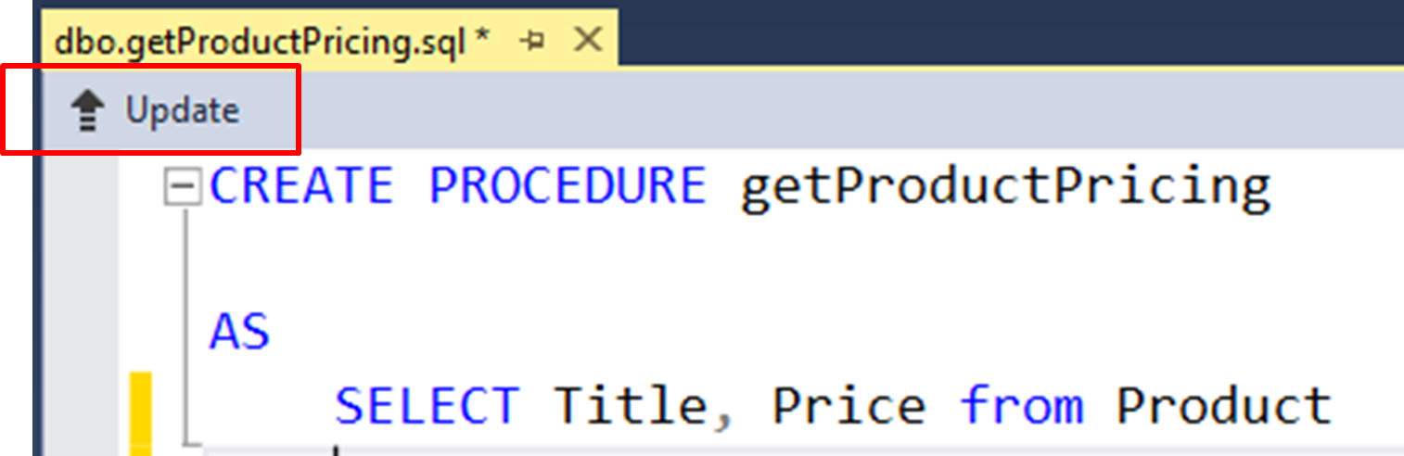

* 1. Click on “**Update Database**” to confirm the update.

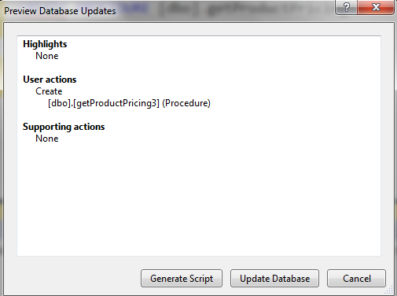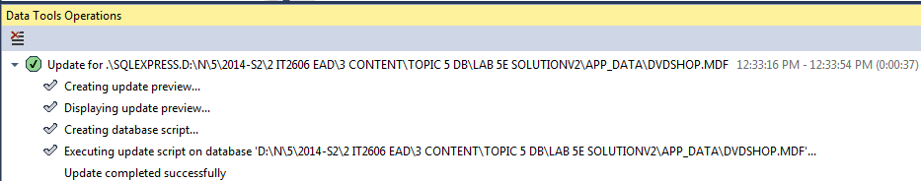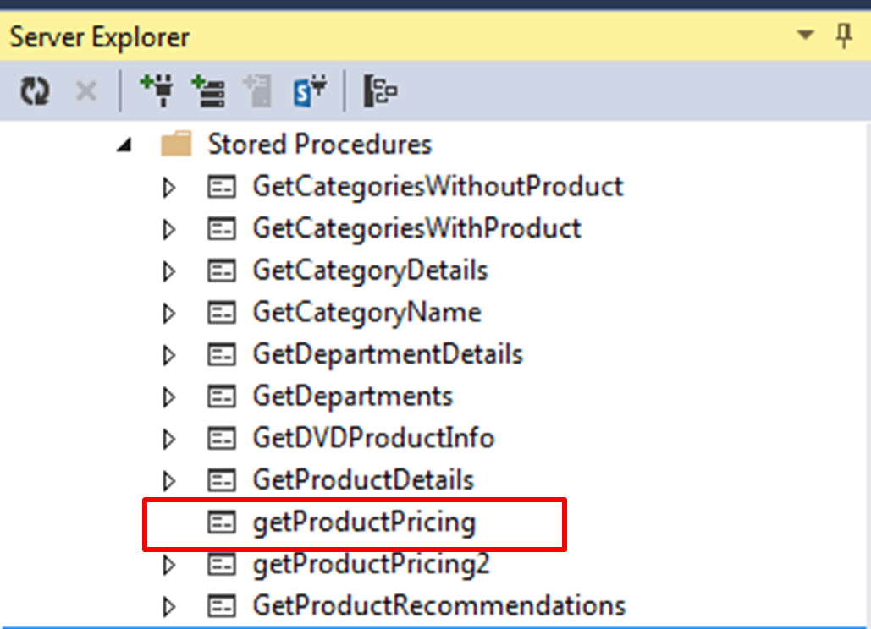

* 1. Create a new web form called Ex1.aspx with button ID = btnRetrieve and Label ID = lblResult :

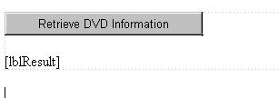

* 1. In the button click even handler, pass the name of the Stored Procedure getProductPricing you created in 1.2 as a parameter into SqlCommand.

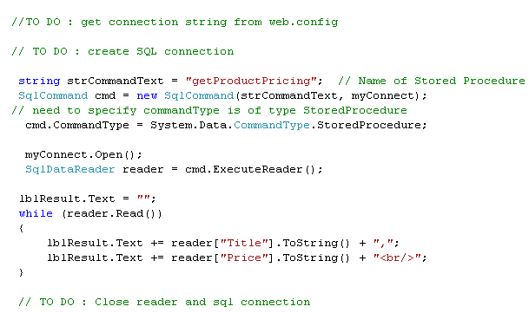

* 1. Build and test out your program.

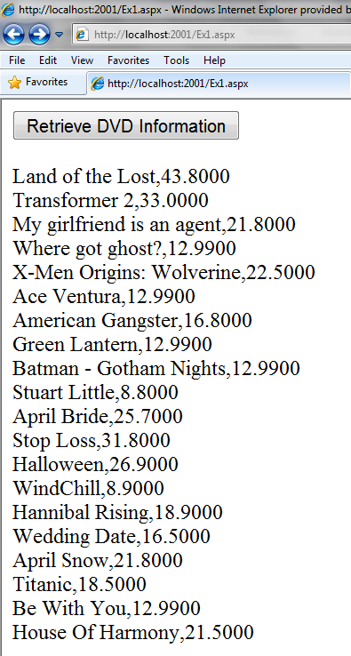

**Exercise 2 Calling Stored Procedure with input Parameter**

We now want to be able to pass input parameters into a Stored Procedure.

2.1 Following Step 1.1 to 1.4 above, create a new Stored Procedure called **getProductPricing2**.

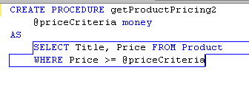

2.4 Create a new web form **Ex2.aspx**. with button ID = btnRetrive, label ID = lblResult, Text Box = txtPrice:

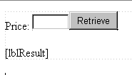

2.5 In button click event handler, add in the necessary codes to create the connection and retrieve from Product Table using the following codes:

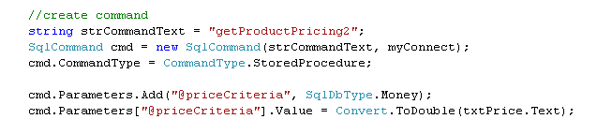

2.6 Build and test your program. Enter 40 into the text box and click on the Retrieve button. You should see only the DVD title “Land of the Lost” displayed.

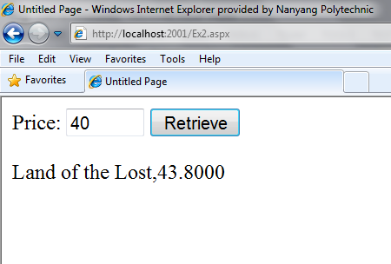

**Additional exercises:**

Attempt to create other stored procedures for the following additional practical exercises:-

1. Create **GetCategoryDetails** stored procedure, and modify your **Lab 5c Exercise 1 getReader() method** to call this newly created stored procedure.
2. Create **GetProductDetails** stored procedure, and modify your **Lab 5c Exercise 2** to call this stored procedure.



**Additional references:**

Visit the following additional practical examples in MSDN

* **Walkthrough: Creating Update Stored Procedures for the Northwind Customers Table 🡺 Visual Studio 2015** 
  + http://msdn.microsoft.com/en-us/library/bb384469.aspx
* **Create a Stored Procedure (SQL Server 2014)**
  + http://msdn.microsoft.com/en-sg/library/ms345415.aspx
* **Walkthrough: Creating Update Stored Procedures for the Northwind Customers Table**
  + http://msdn.microsoft.com/en-us/library/bb384469(v=vs.110).aspx

**========== End ==========**